Experiment No. 1:

Aim: Develop a program to count the occurrences of an element in an array and upload the implementation to GitHub.

Tools:
- Programming Language: C
- IDE: Visual Studio Code

Theory:

An array is a collection of elements stored in contiguous memory locations. Searching an array involves traversing each element to find a specific value. To count the occurrences of an element, each array element is compared with the target element. Whenever a match is found, a counter variable is incremented. After traversing the complete array, the counter gives the total number of occurrences. This demonstrates array traversal, conditional statements, and loop implementation in C. The completed program can then be uploaded to GitHub for version control and collaboration.

Algorithm:
- Start the program.
- Input the size of the array.
- Enter the array elements.
- Input the element to be searched.
- Initialize a counter to 0.
- Traverse the array.
- If an element matches the target, increment the counter.
- Display the total occurrences.
- Upload the code to GitHub.
- End the program.

Program:

#include <stdio.h>

int main(){
int n,x,count=0;
int firstPosition = 1;

printf("Enter the size of the array: ");
scanf("%d",&n);
int array[n];
for(int i=0; i<n;i++){
printf("Enter element %d: ",i+1);
scanf("%d",&array[i]);
}

printf("Enter the elment whose occurence you would like to find: ");
scanf("%d",&x);

for(int i=0; i<n;i++){
if(array[i]==x){
count++;
printf("The first position of the element is %d and it occurs %d time",firstPosition,count);
}else{
firstPosition++;
}

}

return 0;
}

Output:
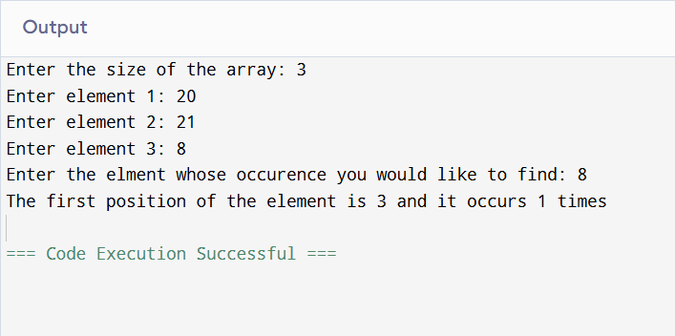

Learning Outcome:

LO1.1 Understand array operations.
LO1.2 Analyse linear search complexity.
LO1.3 Manage source code using GitHub.

Course Outcome:
After completion of the course the learner should be able to:
CO1: Differentiate linear and non-linear data structures based on their organization, operations, and
. computational efficiency.
CO2: Demonstrate the use of stacks and queues to solve real-world computational problems.
CO3: Implement and analyse linked list structures and their operations for dynamic data management.
CO4: Make use of tree structures for hierarchical data representation and efficient searching.
CO5: Examine real-world problems using graph data structures and associated techniques.
CO6: Evaluate advanced data structures based on performance characteristics and application
requirements.

Conclusion:
Successfully developed a C program to count the occurrences of an element in an array and learned the basics of array traversal and GitHub version control

Viva Questions:
1. What is an array?
An array is a collection of elements of the same data type stored in contiguous memory locations. It is used to store multiple values under a single variable name.

2. How do you count the occurrences of an element in an array?
Traverse the array using a loop and compare each element with the target element. If they match, increment a counter. The final value of the counter gives the total occurrences.

3. What is the purpose of GitHub in this experiment?
GitHub is used to store, manage, and share the source code online. It also helps in version control and collaboration.

For Faculty Use

Correction Parameters | Formative Assessment [40%] | Timely completion of Practical [ 40%] | Attendance / Learning  Attitude [20%]
Marks Obtained

